TEKS Scaffold (for use with STAAR data only)

The TEKS Scaffold tool allows the user to select one or more years of STAAR assessments in each Checkpoint to populate data for aligned Student Expectations on the lead4ward TEKS Scaffold document (Excel format).

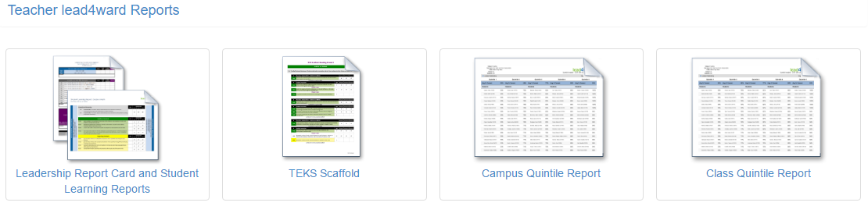

After selecting TEKS Scaffold from the report listing, the following search page will appear:
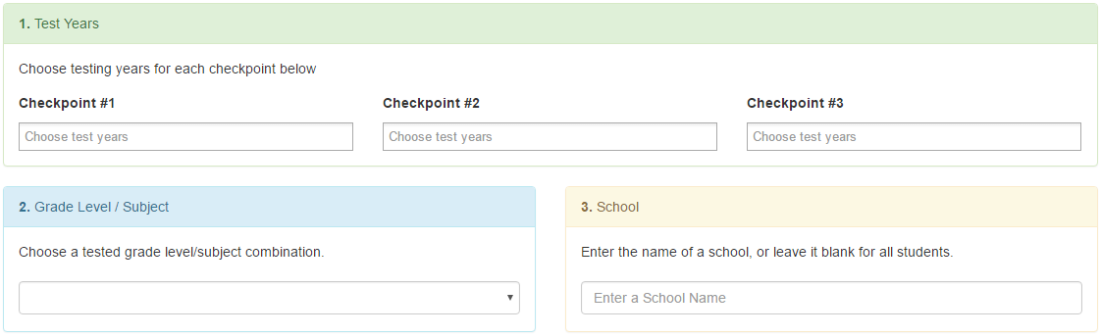

Click the Checkpoint and choose a year from the drop-down menu. Each Checkpoint can have one year of STAAR data or multiple years aggregated together (as though they were one big test).

Next, choose the Grade Level/Subject from the drop-down menu.

When finished, click “Print Report” to generate the lead4ward TEKS Scaffold in Excel format.
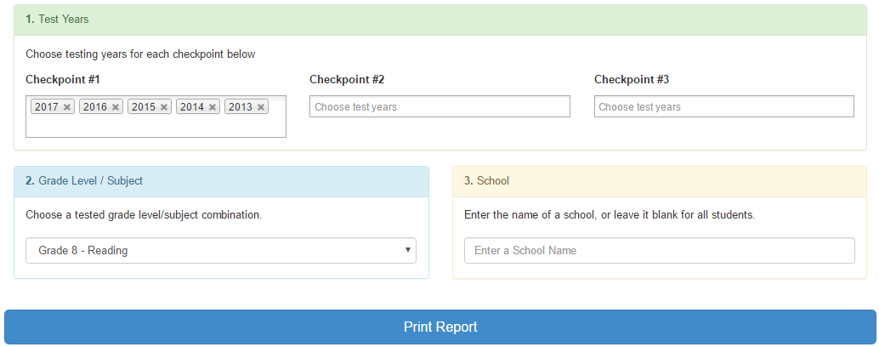

The Excel file that generates will have multiple worksheets, or tabs, at the bottom. See image below for an example for a Reading TEKS Scaffold. The “Launchpad” tab includes descriptors and direct links to all other tabs on the report.

Below is a sample selection from a Grade 8 Reading TEKS Scaffold.

To view more than 3 grade levels below:
- select rows as shown on this example
- right click
- select “Unhide”

Expanded TEKS Scaffold

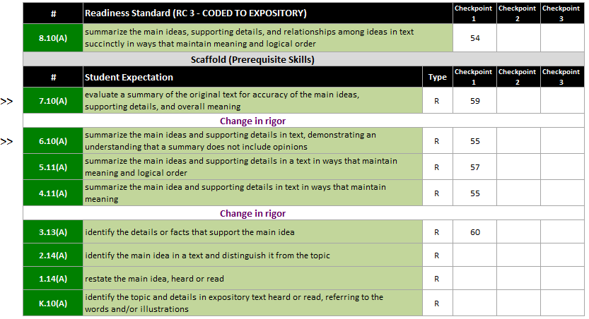

TEKS Scaffolds are great tools for vertically aligning student expectations (SEs) and investigating concept development across grade levels. TEKS Scaffolds are organized by Process and Readiness Standards as individual tabs on the report.

Where applicable, “>>” symbols are used to help teachers identify suggested standards for pre-assessment to determine where to begin instruction (if needed).

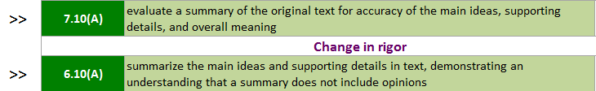

TEKS Scaffolds also include “Change in rigor” notations, where applicable, within vertically aligned standards.

Important Notes:
- TEKS Scaffold reports include the vertical alignment of SEs from the chosen grade level of the report all the way to Kindergarten. Vertically-aligned standards that are not included in state-assessed curricula will have no data.
- Grades 3-8 Math will populate using a template that includes only the student expectations (adopted in 2012) that were implemented and assessed beginning in the 2014-2015 school year. For TEKS Scaffold Reports using grades 3-8 Math, do not include STAAR years prior to 2015.
- Algebra 1 will populate using a template that includes the Algebra 1 student expectations (adopted in 2012) that will be implemented and assessed beginning in the 2015-2016 school year, as well as the vertically-aligned SEs from the lower grade levels. For TEKS Scaffold Reports using Algebra 1, do not include STAAR years prior to 2016.

